**Practice Questions**

**Question 01:**

**Code:**

package com.company;  
  
import java.util.Scanner;  
  
public class Question01 {  
  
 public static void main(String[] args) {  
  
 int num;  
 int first_digit;  
 int second_digit;  
 int third_digit;  
  
 Scanner sc = new Scanner(System.*in*);  
  
 System.*out*.print("Enter a three digit number: ");  
 num = sc.nextInt();  
  
 first_digit = num / 100;  
 second_digit = (num % 100) / 10;  
 third_digit = (num % 100) % 10;  
  
 System.*out*.println("The sum of the product of its digits is " + (first_digit * second_digit * third_digit));  
 sc.close();  
 }  
}

**Output Screenshot:**

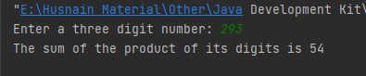

**Question 02:**

**Code:**

package com.company;  
  
import java.util.Scanner;  
import java.util.Arrays;  
  
public class Question02 {  
  
 public static void main(String[] args) {  
  
 int [] num_array = new int [4];  
  
 Scanner sc = new Scanner(System.*in*);  
  
 for (int i = 0; i < 4; i++){  
  
 System.*out*.printf("Enter Num-%d: ", i+1);  
 num_array[i] = sc.nextInt();  
 }  
 Arrays.*sort*(num_array);  
  
 System.*out*.println();  
 System.*out*.println("Smallest Number: " + num_array[0]);  
 System.*out*.print("Largest Number: " + num_array[3]);  
 sc.close();  
 }  
}

**Output Screenshot:**

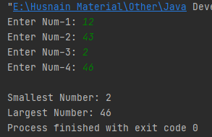

**Question 03:**

**Code:**

package com.company;  
  
import java.util.Scanner;  
  
public class AgeIn5 {  
  
 public static void main(String[] args) {  
  
 String name;  
 int age;  
  
 Scanner sc = new Scanner(System.*in*);  
  
 System.*out*.print("Enter your name: ");  
 name = sc.nextLine();  
  
 System.*out*.println();  
 System.*out*.printf("Hi, %s! How old are you? ", name);  
 age = sc.nextInt();  
  
 System.*out*.println();  
 System.*out*.printf("%s, in five years you will be %d years old.\n", name, age+5);  
 System.*out*.printf("And five years ago you were %d!", age-5);  
 sc.close();  
 }  
}

**Output Screenshot:**

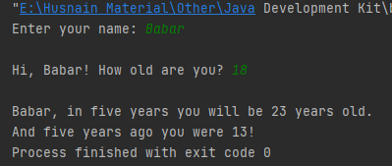

**Question 04:**

**Code:**

package com.company;  
  
import java.util.Scanner;  
  
public class Question04 {  
  
 public static void main(String[] args) {  
  
 int num_1;  
 int num_2;  
 String option;  
  
 Scanner sc = new Scanner(System.*in*);  
  
 System.*out*.print("Enter number 1: ");  
 num_1 = sc.nextInt();  
 System.*out*.print("Enter number 2: ");  
 num_2 = sc.nextInt();  
  
 System.*out*.println();  
 System.*out*.print("Choose operation (+,-,*,/): ");  
 option = sc.next();  
 System.*out*.println();  
  
 switch (option) {  
 case "Addition" -> System.*out*.printf("%d + %d = %d", num_1, num_2, num_1 + num_2);  
 case "Subtraction" -> System.*out*.printf("%d - %d = %d", num_1, num_2, num_1 - num_2);  
 case "Multiplication" -> System.*out*.printf("%d * %d = %d", num_1, num_2, num_1 * num_2);  
 case "Division" -> System.*out*.printf("%d / %d = %.2f", num_1, num_2, (float) num_1 / num_2);  
 default -> System.*out*.print("Please enter a valid operation!");  
 }  
 sc.close();  
 }  
}

**Output Screenshot:**

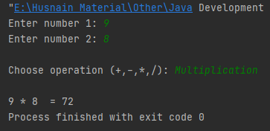

**Question 05:**

**Code:**

package com.company;  
  
import java.util.Scanner;  
  
public class Question05 {  
  
 public static void main(String[] args) {  
  
 int units;  
 float temp_bill = 0;  
 float total_bill;  
  
 Scanner sc = new Scanner(System.*in*);  
  
 System.*out*.print("Enter the number of units: ");  
 units = sc.nextInt();  
 System.*out*.println();  
  
 if (units <= 100){  
 temp_bill = 4.0F * units;  
 }if (units > 100 && units <= 300){  
 temp_bill = 4.5F * units;  
 }if (units > 300 && units <= 500){  
 temp_bill = 4.75F * units;  
 }if (units > 500){  
 temp_bill = 5.0F * units;  
 }  
 total_bill = (temp_bill * 0.2F) + (temp_bill * 0.1F) + temp_bill;  
 System.*out*.println("Total Bill = Rs." + total_bill);  
 sc.close();  
 }  
}

**Output Screenshot:**

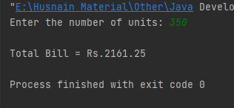

**Question 06:**

**Code:**

package com.company;  
  
import java.util.Scanner;  
  
public class Question06 {  
  
 public static void main(String[] args) {  
  
 int [] [] factories = new int [4] [3];  
 String [] items = {"Bio-Degradable","Non-Biodegradable","Recyclable"};  
 int [] total_items = new int [3];  
  
 Scanner sc = new Scanner(System.*in*);  
  
 for (int i = 0; i < 3; i++){  
  
 for (int j = 0; j < 4; j++){  
  
 System.*out*.printf("Number of %s products produced by Factory %d: ", items[i], j+1);  
 factories[j][i] = sc.nextInt();  
 total_items[i] += factories[j][i];  
  
 }  
 System.*out*.println();  
 }  
 System.*out*.println();  
 System.*out*.println("\t\t\t\t\tFactory 01\t\tFactory 02\t\tFactory 03\t\tFactory 04");  
 System.*out*.println("\t\t\t\t\t----------\t\t----------\t\t----------\t\t----------");  
  
  
 System.*out*.printf("%s\t\t\t%d\t\t\t\t%d\t\t\t\t%d\t\t\t\t%d\n\n", items[0], factories[0][0], factories[1][0], factories[2][0], factories[3][0]);  
 System.*out*.printf("%s\t\t%d\t\t\t\t%d\t\t\t\t%d\t\t\t\t%d\n\n", items[1], factories[0][1], factories[1][1], factories[2][1], factories[3][1]);  
 System.*out*.printf("%s\t\t\t\t%d\t\t\t\t%d\t\t\t\t%d\t\t\t\t%d\n\n", items[2], factories[0][2], factories[1][2], factories[2][2], factories[3][2]);  
  
 System.*out*.println();  
 System.*out*.println("Total Bio-Degradable Items: " + total_items[0]);  
 System.*out*.println("Total Non-Biodegradable Items: " + total_items[1]);  
 System.*out*.println("Total Recyclable Items: " + total_items[2]);  
 sc.close();  
 }  
}

**Output Screenshot:**



